Software Architect and Design Project

Project Name : Education Chat room & Management System

Name : Anuradha Gude

Table of Content: Project Update

|  |  |  |
| --- | --- | --- |
| SR. No. | Content | Page No. |
| 1 | Introduction | 1 |
| 2 | Requirement and language specification | 2 |
| 3 | Project Structure | 3 |
| 4 | Project Progress Report Phase 3 | 4 |
| 4.1 | UML Diagram | 4 |
| 4.2 | User Interface | 5 |
| 5 | Project Progress Report Phase 4 | 6 |
| 6 | Conclusion | 8 |

**Introduction :**

In this project, I want to build a software system to connect students and faculties. Here students can interact with other students, access and submit academic resources, and learn about different clubs and chapters.

●**Admins** are in charge of managing and maintaining the server, as well as controlling the resource database in the event of redundant files.

●**Students** - They can interact with other students, access and submit academic resources, and learn about different clubs and chapters.

●**Faculty** - They can communicate with students and post crucial university or exam-related news. They could also upload a variety of academic resources, such as books, for the benefit of pupils.

Three primary components will make up the online portal. By creating a room for the same topic, students will be able to communicate and discuss with other students or faculty members.

There are few Non-Functional requirements as well –

1. The web portal must load within 5 seconds.
2. User authentication must be completed within 2 seconds.
3. The chat must be updated minimum every 500 milliseconds to provide efficient communication.
4. The database for resources should handle files of any size.
5. The portal must be accessible from anywhere with minimum megabit internetS
6. Callability
7. Availability
8. Reliability
9. Recoverability

**Requirements and language specification:**

**Tools Used**

1. IntelIj
2. Sql Workspace

## Front - End : Thymeleaf

## Backend:

## Java

## SQL

## Full stack:

Maven Module with some of the dependencies

1. Spring Web
2. Spring Data JPA
3. MySQL Driver
4. Spring boot DevTools
5. Thymeleaf

**Project Structure : -MVC Model**

The structure of the project looks like as follow :

**Controllers:**

1. Controller Class

**Services**

1. Student Service
2. Faculty Service
3. Session Service

**Repositories**

1. StudentRepository
2. FacultyRepository
3. SessionRepository

**DataBase Tables**

1. Student_table
2. Faculty_table
3. Sessions

With Primary keys as ID

**Project Progress Report Phase 3**

To create such kind of website we did a lot of research on the internet as well as on other resources. After successive surfing on the internet, I choose design patterns to follow. I also created the UML diagram for which looks as follows:

The Faculty and Students access the Portal through the Internet. Admin manages and maintains the server while the actors access rights to different parts of the System. "Students," "Faculties," and "Administrators" are the four main user groups.

Users will log into the system using their web browsers, and a dynamic user-specific page will be served to them based on their profile and access rights. Students have access to a resource database where they can upload and download various course materials as well as exam papers from past years.

The final UML Diagram looks like as follow :

**UML DIAGRAM:**

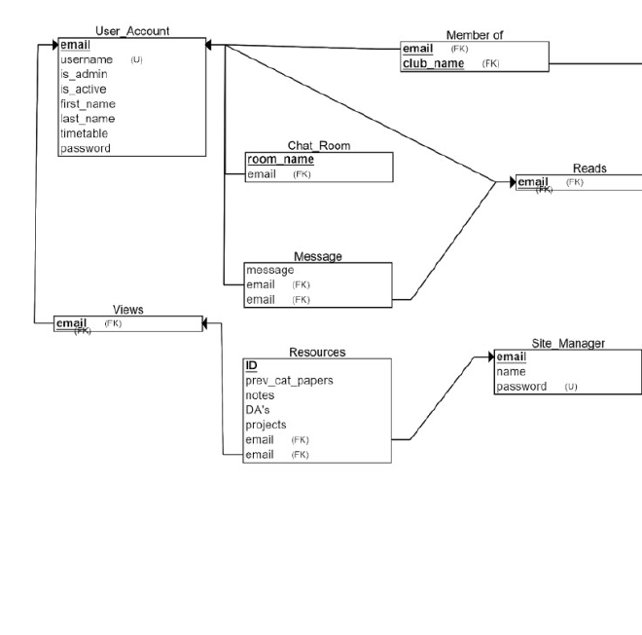

**User Interface:**

**Project Progress Report Phase 4**

This is the final phase of the project. Here I have completed the following things to complete the project:

1. **Integrating the features altogether :**

In this part, I have integrated all the functionality like the chat room, User login, dashboard, management, etc. Now all the functionalities are combined together in this project.

1. Working on the GUI:

For any software, the Graphical User Interface is the foremost important thing. The graphical Interface should be simple & user-friendly. In this phase, I tried to make the user interface more interesting.

The view of final project looks as follows:

1. Dashboard

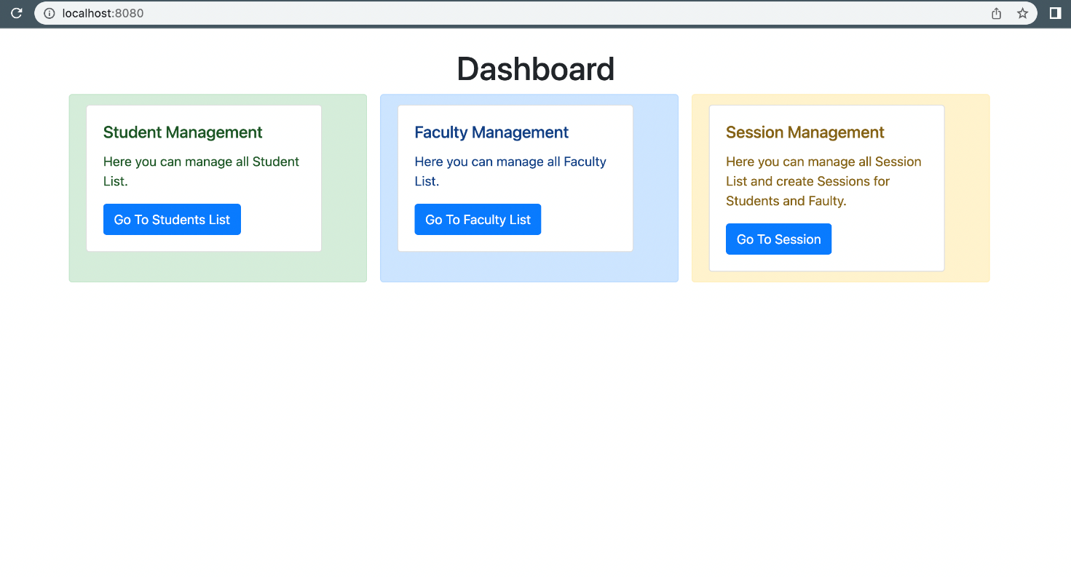

1. Student List

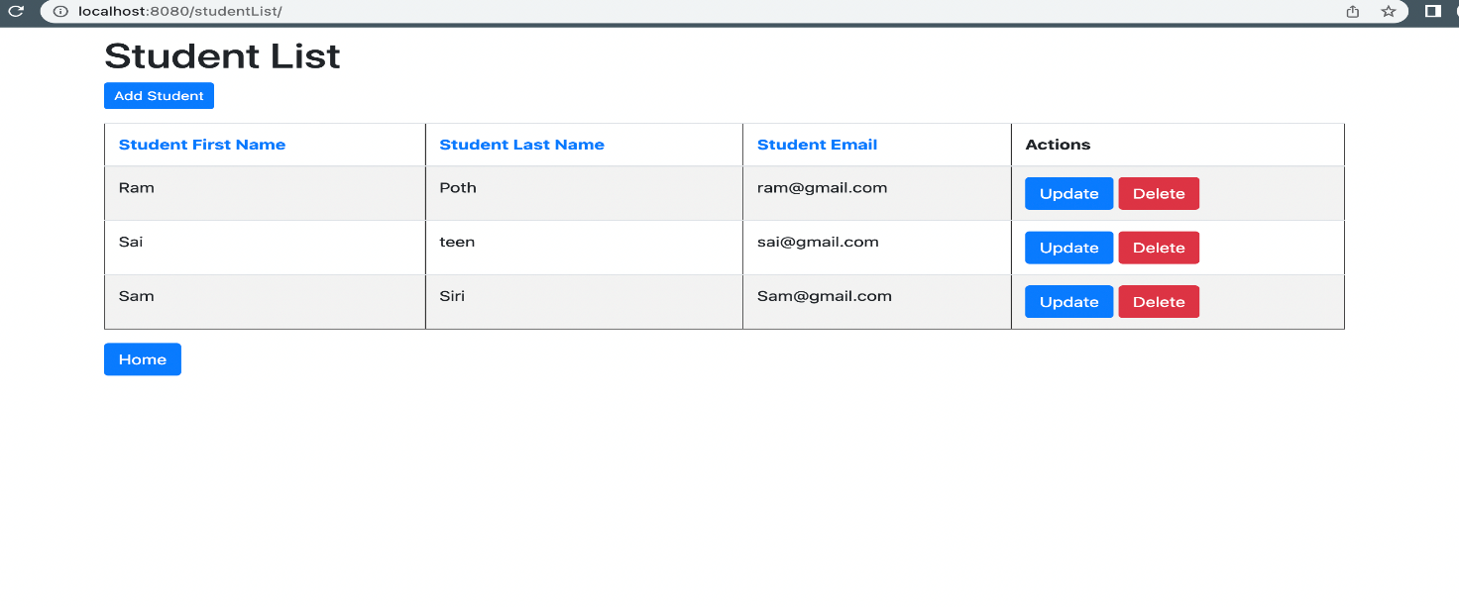

1. Insert New Student

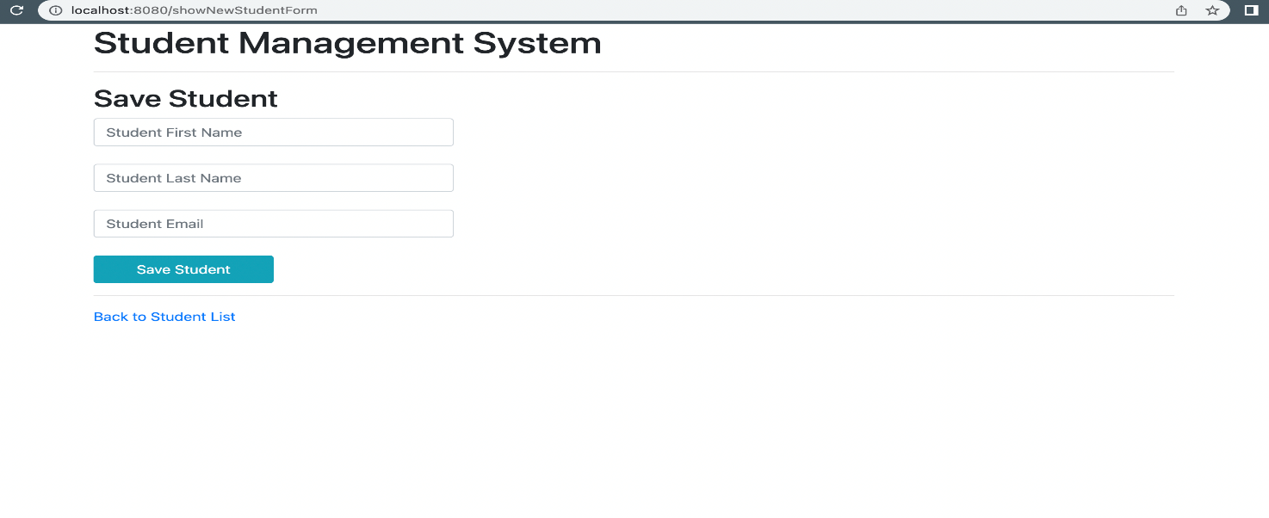

1. Update the existing student details

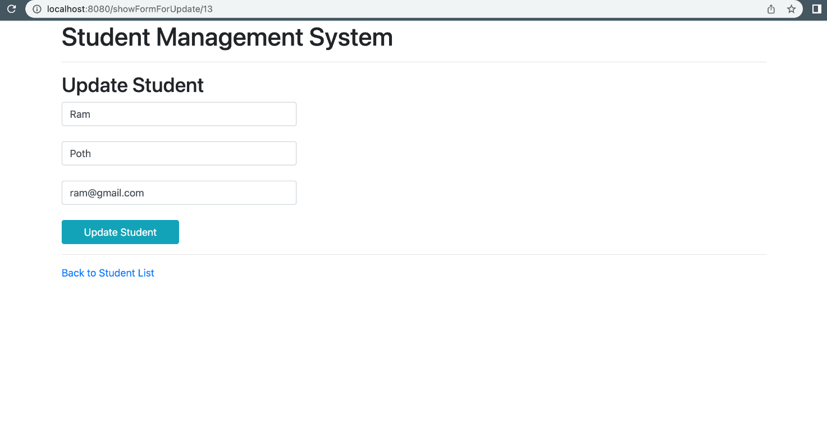

1. Add New Faculty

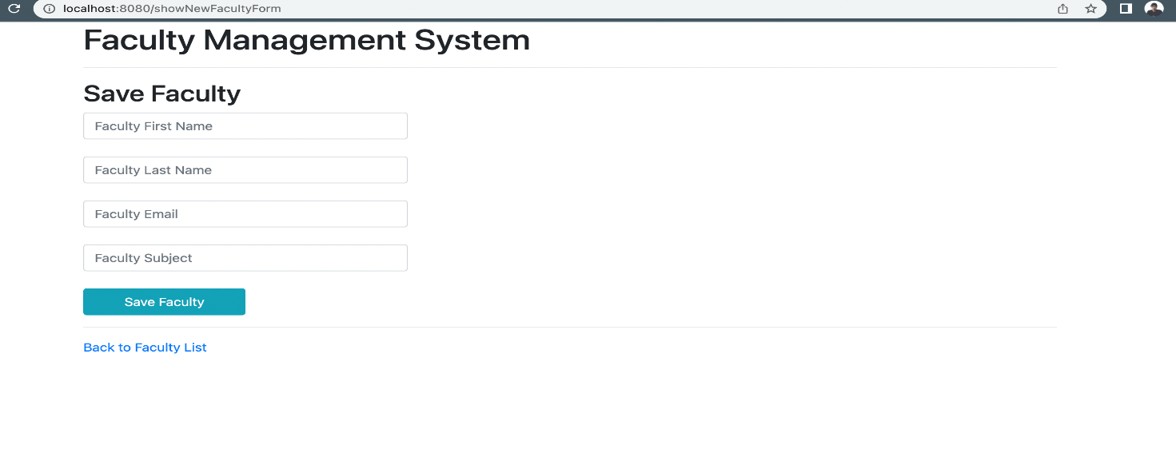

1. Add a Session

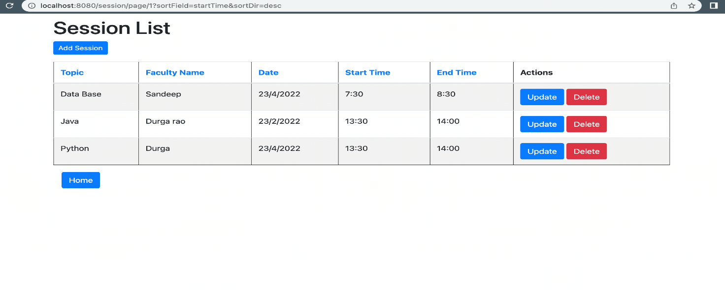

1. Update Season

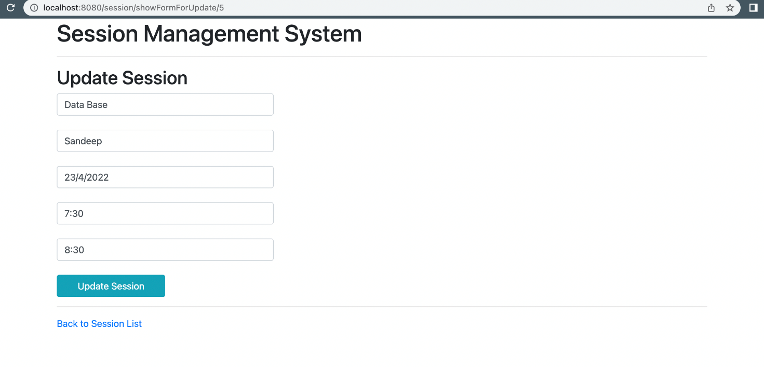

1. Updating the security

In the end, I also worked on some security aspects to make the environment secure and error-free. I applied a few tests for all the components and at the end system testing.

**Conclusion:**

Software systems are always interesting to work on. In this project, I worked on java to create an “Education Chat room & Management System”. I learned a lot while working on this project. This knowledge might help us to work on real time projects.